**Name:-Abhay Ulhas Kumawat Roll No:- 178 Batch:- B6**

**Div:- B**

**Title:-5 Perform a Title on node js installation .**

**Step:1**

Open **Google crome** and search **node js download** and open the above website.

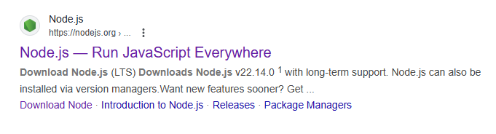

**Step:2**

Click **Download Node.js(LTS).**

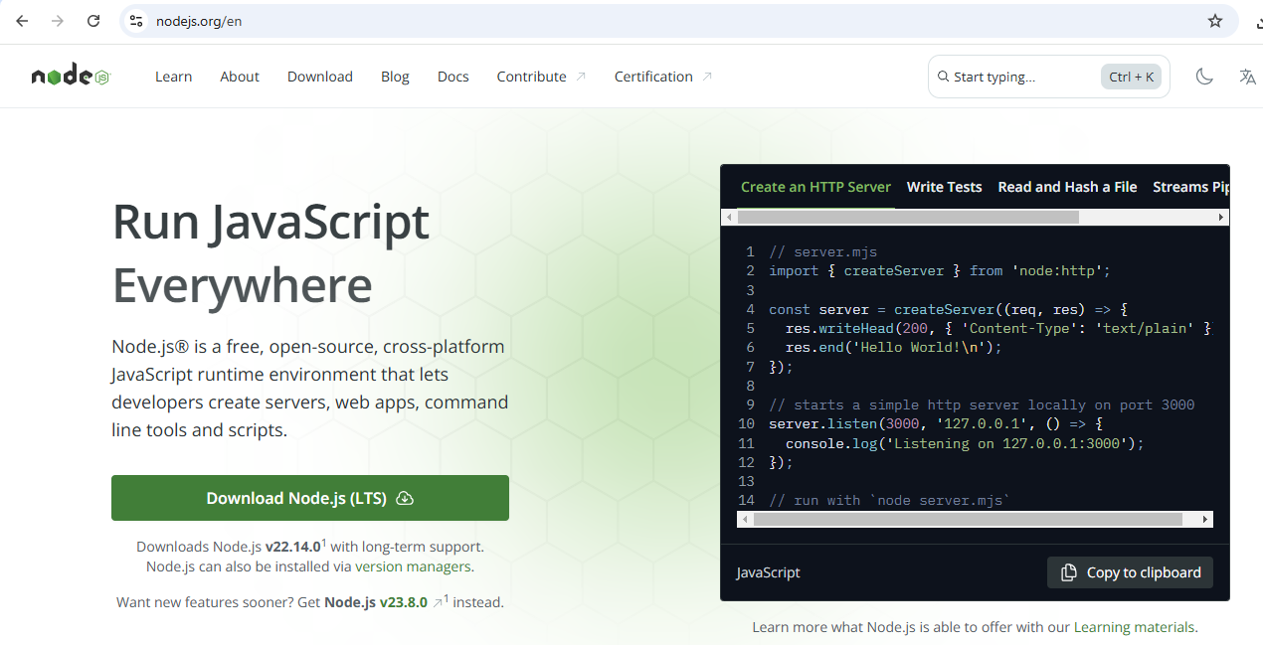

**Step:3**

Your **Download** will begin.

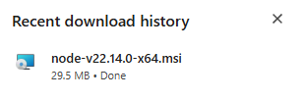

**Step:4**

Then go to **this pc** and double click on **node js** and install it.

**Step:5**

Then open to the command prompt and type command node –v and npm –v

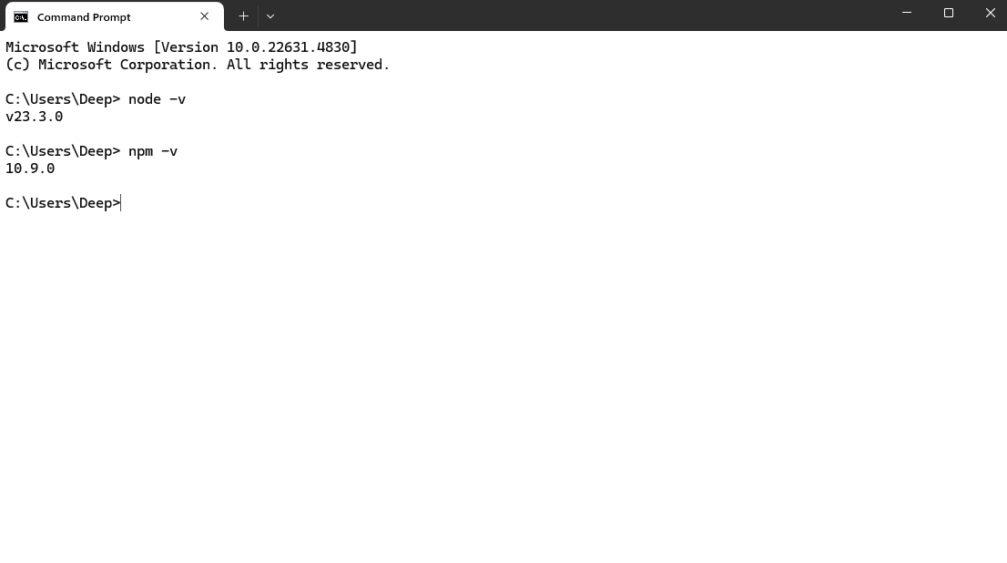

**Name:-Abhay Ulhas Kumawat Roll No:- 178 Batch:- B6**

**Div:- B**

**Title:- 7 Create a REST API with Node.js • Develop a basic REST API using Node.js that performs CR (Create, Read) operations on a simple data set.**

Step 1: Install Node.js and Initialize Your Project

Step 2: Create the API (server.js)

**Server.js:-**

// Import express to create the server

const express = require('express');

// Create an express application

const app = express();

// Define a port number

const port = 3000;

// Use middleware to parse JSON data from requests

app.use(express.json());

// Sample data for demonstration

let users = [

{ id: 1, name: 'Deep', age: 18 },

{ id: 2, name: 'Rohan', age:19 }

];

// 1. Create (POST) operation to add a new user

app.post('/users', (req, res) => {

const { name, age } = req.body; // Extract name and age from request body

// Generate a new user ID

const newUser = {

id: users.length + 1,

name,

age

};

// Add the new user to the "users" data

users.push(newUser);

// Respond with the newly created user data

res.status(201).json(newUser);

});

// 2. Read (GET) operation to get all users

app.get('/users', (req, res) => {

// Respond with all users in the data

res.json(users);

});

// Start the server

app.listen(port, () => {

console.log(`Server is running on http://localhost:${port}`);

});

Step 3: Run the Server

Step 4: Test the API

**Create a New User (POST):**

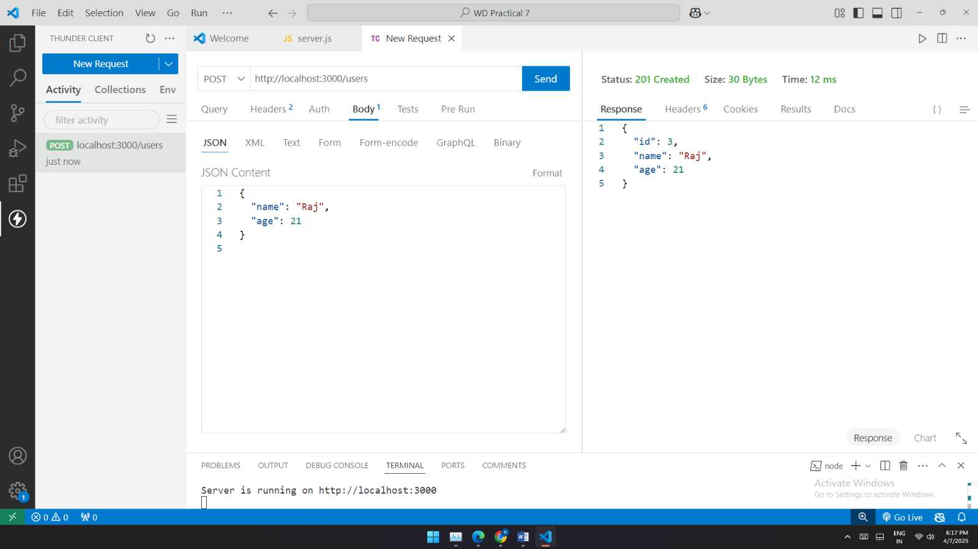

**Get All Users (GET):**

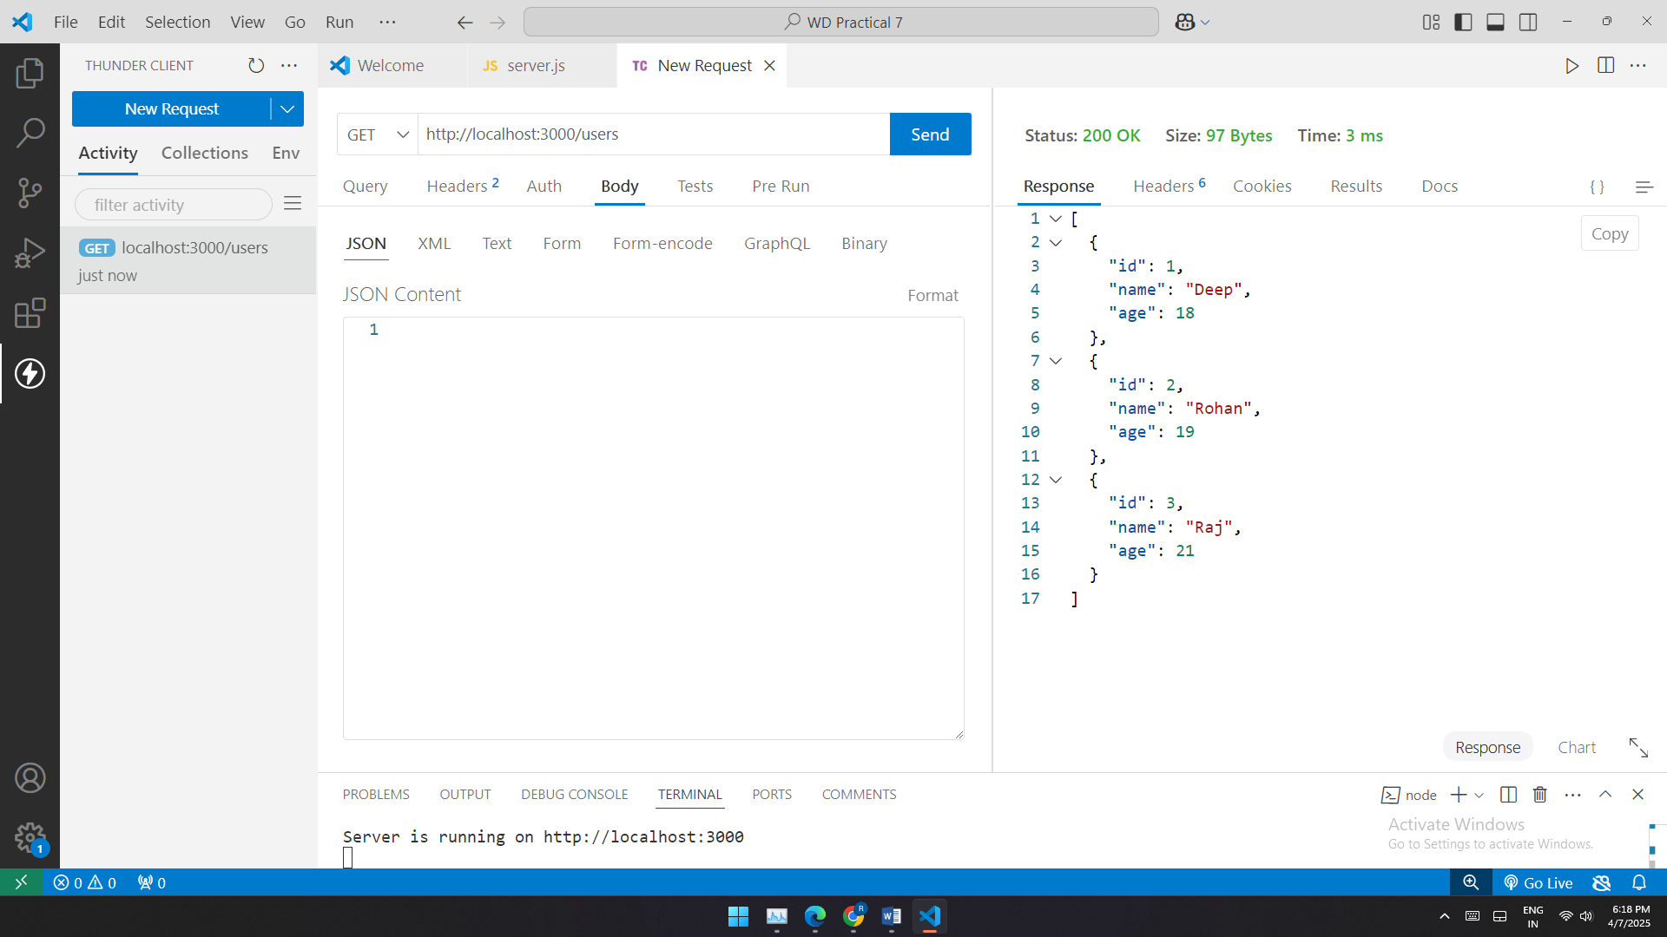

**Name:-Abhay Ulhas Kumawat Roll No:- 178 Batch:- B6**

**Div:- B**

**Prcatical no 4:Event Handling:Develop a web page where javascript respond to event(e.g,button clicks).**

<!DOCTYPE html>

<html lang="en">

<head>

    <meta charset="UTF-8">

    <meta name="viewport" content="width=device-width, initial-scale=1.0">

    <title>addEventListener Example</title>

    <style>

        body{

            font-family: cursive;

            padding: 30px;

        }

        .button-container{

            margin-top: 30px;

        }

        #message{

            margin-top: 30px;

            font-size: 1.6rem;

            font-weight: bold;

        }

        .hightlight{

            background-color: rgb(21, 69, 99);

        }

        </style>

</head>

<body>

    <h1>JavaScript Event Handling</h1>

    <button id="myButton">Touch me!</button>

<button id="ChangetextButton">Change Text </button>

<p id="message">This is original text </p>

<button id="hightlighttextbutton">Highlight Text</button>

    <script>

       //pop up

        document.getElementById("myButton").addEventListener("click", function() {

            alert("SUCCESSFUL !");

        });

//text change

document.getElementById("ChangetextButton").addEventListener("click",function()

        {

            document.getElementById("message").innerHTML="You Have Change The Text"

        });

    //mouseover

    document.getElementById("ChangetextButton").addEventListener("mouseover",function()

{

    document.getElementById("ChangetextButton").style.background="cyan";

});

//mouseout

document.getElementById("ChangetextButton").addEventListener("mouseout",function()

{

    document.getElementById("ChangetextButton").style.background="red";

});

//hightlight

document.getElementById("hightlighttextbutton").addEventListener("click",function()

        {

            const messageElement= document.getElementById("message");

            messageElement.classList.toggle("hightlight"); // Toggle highlight class

        });

    </script>

</body>

</html>

**output:**

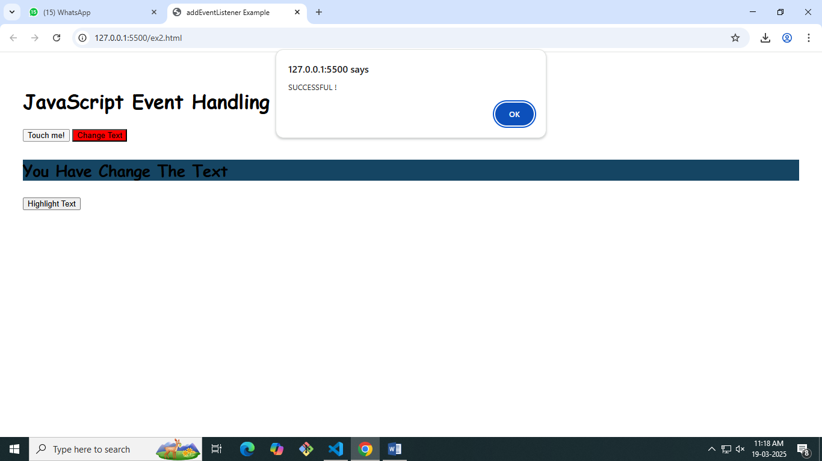

**Name:-Abhay Ulhas Kumawat Roll No:- 178 Batch:- B6**

**Div:- B**

**PRACTICAL: 6 Create a basic HTTP server using node.js that respond with “hello world! To my request**

**Server.js file**

const http = require("http");

const server = http.createServer((req,res)=> {

res.writeHead(200,{"content-type":"text/plain"});

res.end("hello everyone wellcome to my web page!");

});

const PORT = 3001;

server.listen(PORT, () =>{

    console.log(`server is running at http://localhost:${PORT}`);

});

**OUTPUT:**

